TASK 2: Exploratory Data Analysis (EDA)
  - Ask meaningful questions about the dataset before analysis.
  - Explore the data structure, including variables and data types.
  - Identify trends, patterns and anomalies within the data.
  - Test hypotheses and validate assumptions using statistics and visualization.
  - Detect potential data issues or problems to address in further analysis.

Meaningful questions about the dataset before analysis.
What is the target variable and how is it distributed?

The target variable is Diagnosis, which represents whether a thyroid tumor is benign or malignant. It was encoded as a binary variable where benign cases are labeled as 1 and malignant cases as 0. The class distribution was examined using value counts, revealing the proportion of each diagnosis category.

Which features might influence the target?
The features most likely to influence the target variable (Diagnosis) include Nodule_Size, thyroid hormone levels (TSH, T3, T4), Radiation_Exposure, Family_History, Iodine_Deficiency, and the derived Thyroid_Cancer_Risk feature. These variables demonstrated moderate to strong correlation with the diagnosis outcome and are clinically meaningful. Demographic variables such as country and ethnicity showed weaker influence, while lifestyle factors like smoking and obesity had limited individual impact.


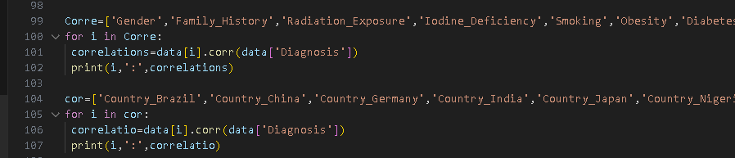
Are there imbalances (e.g., more of one class)?
The class distribution of the target variable (Diagnosis) was examined using value counts, which revealed an imbalance between benign and malignant cases. To address this, stratified sampling was applied during the train-test split to ensure that both training and testing datasets retained the original class proportions.
Are numerical values normally distributed or skewed?
Distributional analysis using histograms and mean–median comparison indicates that numerical features are not strictly normally distributed and exhibit skewness. In particular, the Thyroid_Cancer_Risk variable shows an asymmetric distribution, supported by the difference between its mean and median. Similar behavior is observed in Nodule_Size, suggesting the presence of skewed numerical features that may benefit from scaling or transformation in later stages.
Explore the data structure, including variables and data types.
The dataset structure was explored by examining its dimensions, column names, and data types. The data contains a mix of numerical, categorical, and ordinal variables. Initial inspection revealed inconsistencies such as numeric values stored as text and categorical variables requiring encoding. Appropriate type conversions and encoding techniques were applied, resulting in a fully numeric dataset suitable for correlation analysis and machine learning models.
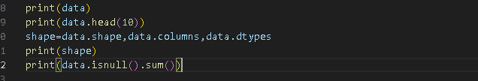
Identify trends, patterns and anomalies within the data.
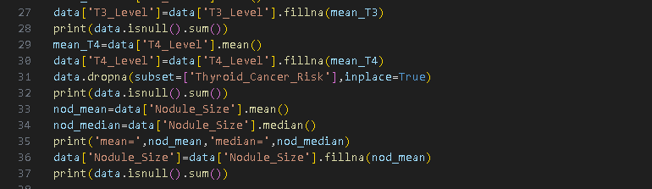
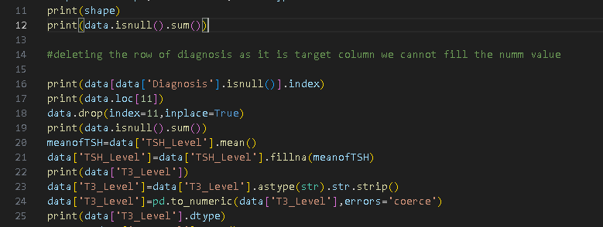
Detect potential data issues or problems to address in further analysis.
The EDA revealed several potential data issues: missing values in both features and the target, inconsistent numeric and categorical formatting, skewed distributions in features like Nodule_Size and Thyroid_Cancer_Risk, and class imbalance in the target variable. These problems were partially addressed during preprocessing (e.g., imputations, encoding, and stratified splitting), while other issues like skewness and multicollinearity will be handled in later modeling steps.

